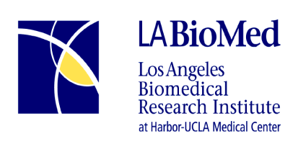

Job Announcement

Job Title: SLAHP Breastfeeding Peer Counselor
Status: Full Time
Job requisition # 17-018
Dept.: SLAHP
Position Open Date: 2/24/2017
Compensation: $ 1,820-$2593 (DOE)

* If you are unable to apply following our standard procedures and need accommodation, please contact us at (310)222-3616.

Required Skills & Qualifications:

The Breastfeeding Peer Counselor I (BFPC I) position requires personal breastfeeding experience that meets the American Academy of Pediatrics recommendation of 4 – 6 months of exclusive breastfeeding followed by continued breastfeeding with the addition of solid foods; knowledge of breastfeeding, including common problems and their solutions; and familiarity with the cultural beliefs and misconceptions common to the community served, which is predominantly Latina and African American. High school diploma or GED required. Strong communication skills are essential. Current or past participation in the WIC Program highly desired. Specialized training in breastfeeding and counseling techniques is provided. Basic keyboard skills and keyboard experience are needed to utilize required databases. Some evening and weekend hours required. Must have personal vehicle, valid California driver’s license and current registration as well as proof of current auto insurance. Background check and health clearance required.

Description of Duties:

- Provide breastfeeding education and support to expectant and new mothers at the WIC site, individually and in groups, and by telephone to encourage mothers to initiate and continue breastfeeding.
- Document client contacts as required in the Peer Counselor and WIC databases.
- Follow established guidelines to build and maintain individual caseload.
- Participate as a team member at assigned WIC site, including participating in site meetings, providing breastfeeding updates, and assisting breastfeeding staff members, as requested
- Other duties as assigned

“Equal Opportunity Employer”
Please apply on-line @ www.labiomed.org

